https://lh3.googleusercontent.com/1Nd8BlGJwEJZ-r9mdvepvj_CdPu-xBC5Gu50tKfMr1oguTrYMqryzeo5jNtK3SAqK3CzjTVxmBc2ODogLVrBabrrpBy5SYUMXUIoVg2hsoV5UljxLkrY6A4te_xjvbFn4jT2Bq8B

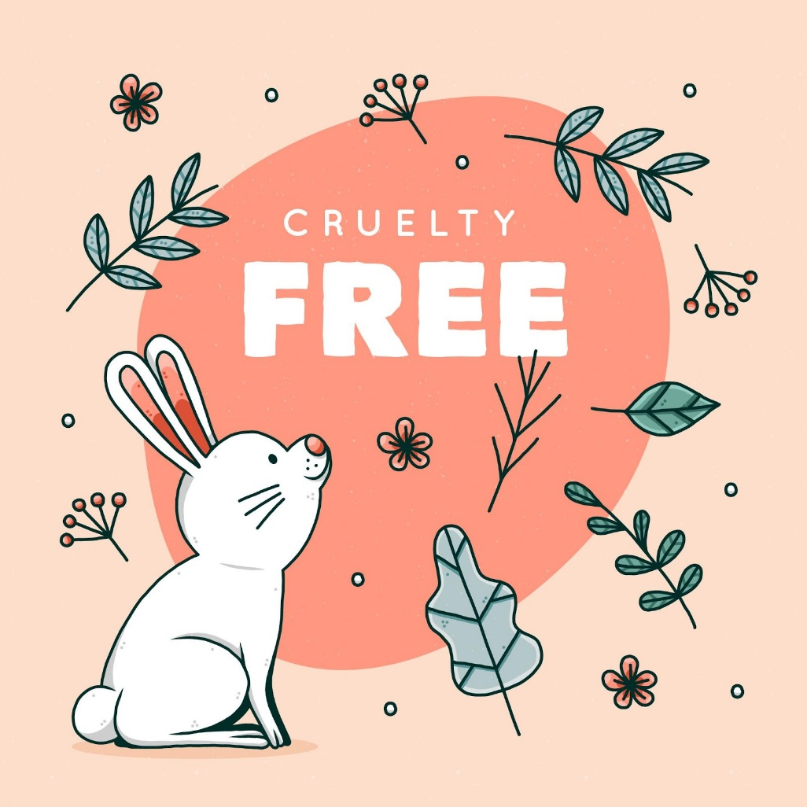

**Death By Cosmetics**

April 25, 2021

**─**

Zysu Tech

Angeles City, Pampanga

Philippines

**Background**

When animals are used in laboratory and cosmetics testing, they are exposed to excruciating discomfort, suffering, and death; animal research must be halted to avoid further waste of animal life. Animals are still being tortured and killed to test shampoo, mascara, and other cosmetics. Before being killed, terrified rabbits, rats, guinea pigs, and mice have substances forced down their throats, dripped into their eyes, or smeared on their skin.

**Problems**

Animal testing for cosmetics is both unethical and unnecessary, since companies can already make revolutionary products with thousands of ingredients that have a long track record of safety and do not need any additional testing. Furthermore, modern research methods (such as human cell-based experiments and sophisticated computer models) have largely replaced obsolete animal tests with non-animal alternatives that are much more efficient.

**Objectives**

1. Establish a voice for the animals through the advocacy website.
2. Spread awareness about animal testing.
3. End cosmetics testing on animals.

**Members and their Roles**

Dasal, Amiel Kurt Menard

*Responsible for the website's coding, design, content, and layout.*

Dulinayan, James

*Responsible for the website's coding, design, content, and layout.*

Fundar, Ithiel Jones

*Responsible for the website's coding, design, content, and layout.*